Wi-Fi Network Security Assessment
Capturing a WPA2 Handshake with a Deauthentication Attack and Recovering the Password
Date of Test: 7 July 2026
Target Network (SSID): cyber_coe_tender
Tools used: airodump-ng, aireplay-ng, hcxpcapngtool, hashcat
A note before you read this
This report was written so that someone with no background in networking or cybersecurity can follow what happened, step by step.
Every technical term is explained in plain English the first time it appears.
This kind of test should only ever be carried out on a network you own or have explicit written permission to test. Doing this against a network without permission is illegal in most countries.

1. What Was Done, in Plain English
This exercise is a demonstration of a common Wi-Fi security weakness test on a WPA2-protected wireless network. The goal was to prove that the network's password could be recovered by an attacker who is simply within radio range of the router — no physical access, and no prior knowledge of the password, was needed.
The test followed four broad stages:
- Listening — putting a Wi-Fi adapter into a special mode so it can 'see' all wireless traffic in the area, not just traffic addressed to it.
- Forcing a handshake — briefly kicking a connected device off the network so that, when it reconnects, it repeats a small piece of encrypted proof (the 'handshake') that can be captured.
- Capturing — saving that handshake to a file.
- Cracking — feeding the captured handshake, along with a huge list of common passwords, into a program that tries each password until one matches.

Key terms used throughout this report
- SSID — the network name you see when you search for Wi-Fi (here, "cyber_coe_tender").
- BSSID — the unique hardware address (MAC address) of the router/access point broadcasting that network.
- Monitor mode — a mode for a Wi-Fi adapter that lets it capture all nearby wireless traffic, rather than just traffic meant for it.
- Deauthentication ("deauth") attack — sending fake "disconnect" messages that trick a device into briefly dropping its Wi-Fi connection, so it has to reconnect.
- Handshake — a short exchange of encrypted data that happens whenever a device connects to a WPA2 network. It doesn't contain the password directly, but it can be used to test password guesses against.
- hashcat — free, widely-used software that tests very large numbers of possible passwords against a captured handshake, extremely quickly, using a computer's graphics card (GPU).
- rockyou.txt — a well-known public wordlist of over 14 million real passwords leaked in past data breaches, commonly used to test how guessable a password is.

2. Step-by-Step Walkthrough

Step 1 — Preparing the Wi-Fi adapter ("monitor mode")
The first step was to switch the wireless adapter (named wlan0) from its normal mode into monitor mode. In its normal mode, a Wi-Fi adapter only pays attention to traffic addressed to it. In monitor mode, it can see all wireless traffic in the air around it, which is necessary to capture other devices' handshakes.
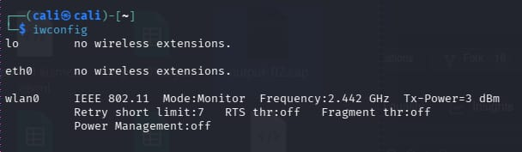
Figure 1: Running 'iwconfig' confirms wlan0 is now in Monitor mode.

Step 2 — Scanning the area for the target network
With the adapter in monitor mode, the next tool, airodump-ng, was used to scan for nearby Wi-Fi networks. This produced a live list of every access point and connected device within range, along with each network's channel, encryption type, and signal strength. The target network, "cyber_coe_te…" (SSID: cyber_coe_tender), was identified in this list on channel 8, using WPA2 encryption.
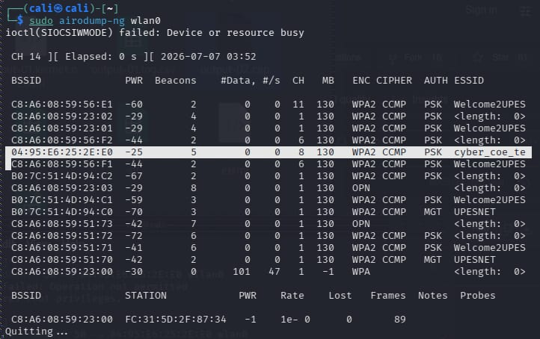
Figure 2: airodump-ng listing nearby networks; the target network appears on channel 8.

Step 3 — Focusing the capture on the target network
Once the target was identified, airodump-ng was re-run with more specific instructions: watch only channel 8, watch only the target's BSSID (04:95:E6:25:2E:E0), and save everything seen to a file named "output". This narrows the capture down to just the traffic relevant to the target network, and is where the handshake will eventually be recorded.
Figure 3: airodump-ng started, focused only on the target network's channel and BSSID, writing to a file called 'output'.

Step 4 — The deauthentication attack
To capture a handshake, a device already connected to the network needs to reconnect while the capture is running. Rather than waiting for that to happen naturally, aireplay-ng was used to send a burst of "deauthentication" frames — forged messages that tell a specific connected device (identified by its MAC address, E2:DB:7D:3A:0D:41) that it has been disconnected. Real Wi-Fi devices are designed to automatically reconnect when this happens, and it is that automatic reconnection which produces the handshake.
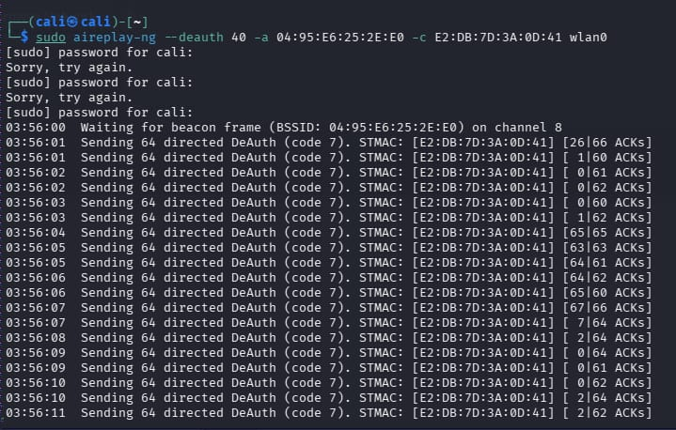
Figure 4: aireplay-ng sending repeated deauthentication frames to the target device, prompting it to reconnect.

Step 5 — Watching the handshake come in
Back in the airodump-ng window, the effect of the deauth attack becomes visible almost immediately: the number of data frames rises sharply as the target device disconnects and reconnects, and the capture window's header changes to show "WPA handshake:" followed by the router's address — confirming a handshake had been captured.
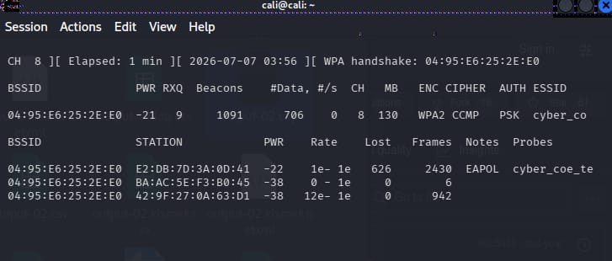
Figure 5: airodump-ng shortly after the deauth attack — frame counts climbing and a handshake already flagged.
A little later, the capture was left running for a further period to make sure a clean copy of the handshake had been recorded, with frame counts continuing to climb.
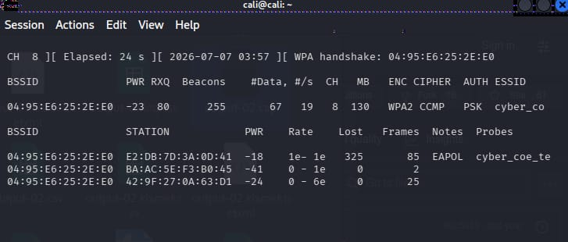
Figure 6: airodump-ng confirming the WPA handshake is still recorded, with additional EAPOL frames captured for reliability.

Step 6 — Saving the capture
The capture produced a set of files in the Downloads folder, including the raw capture file (output-04.cap) which contains the handshake, along with related hashcat-format and password-list files used later in the process.
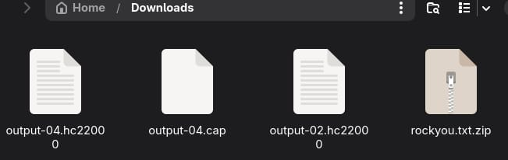
Figure 7: The capture files saved locally, including the .cap file containing the handshake and the rockyou.txt password list (zipped).

3. Converting the Capture and Attempting to Crack the Password

Step 7 — Installing the conversion tool
The raw .cap file isn't in a format hashcat can read directly, so a package called hcxtools was installed. This package provides a converter that turns a raw Wi-Fi capture into the specific format hashcat expects.
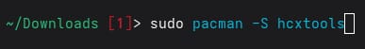
Figure 8: Installing hcxtools, the toolkit needed to convert the capture file into hashcat's format.

Step 8 — Converting the capture file
Using hcxpcapngtool (part of hcxtools), the captured file output-04.cap was converted into output-04.hc22000 — the format hashcat uses for WPA/WPA2 handshakes (hashcat calls this mode "22000").
Figure 9: hcxpcapngtool converting the raw capture into the hashcat-ready output-04.hc22000 file.

Step 9 — First attempt: a missing driver
The first attempt to run hashcat failed. hashcat reported that it could not find a compatible OpenCL, HIP, or CUDA platform — in plain terms, the software that lets hashcat use the computer's graphics card (GPU) for the heavy computation wasn't installed yet. Without it, hashcat has no compatible device to run the password-testing on.
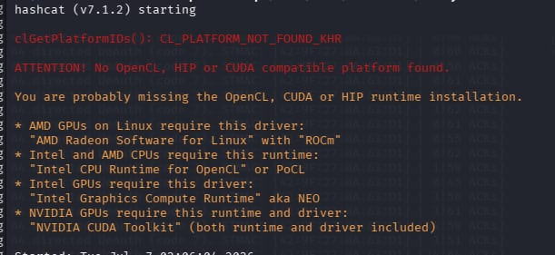
Figure 10: hashcat's first run fails, reporting no OpenCL/CUDA/HIP-compatible platform was found.
This was resolved by installing the correct GPU driver and toolkit (NVIDIA's CUDA toolkit, in this case) so that hashcat could recognise and use the graphics card.

Step 10 — Running hashcat against the handshake
With the driver issue fixed, hashcat was launched again, this time pointed at the converted handshake file (output-04.hc22000) and the rockyou.txt wordlist — a list of over 14 million real, previously-leaked passwords. hashcat's job at this point is simple in concept: take each password from the list, run it through the same mathematical process used when the real device connected, and check whether the result matches the captured handshake. If it matches, that password is correct.
Figure 11: The hashcat command used — mode 22000 (WPA/WPA2), 3 GPU workload threads, the converted handshake file, and the rockyou.txt wordlist.
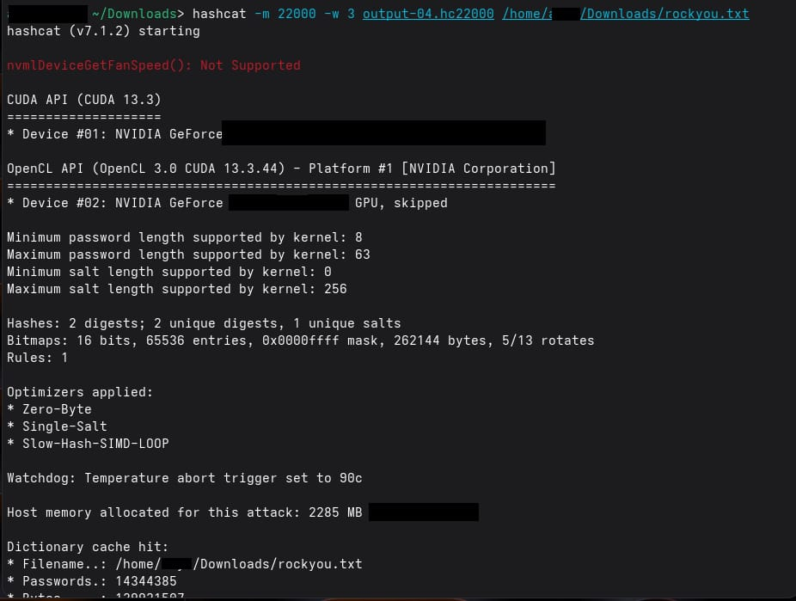
Figure 12: hashcat starting up successfully — detecting the GPU, loading the handshake (2 digests found) and the 14,344,385-password dictionary.

Step 11 — Success: the password is recovered
After working through the wordlist, hashcat found a match. The output line below shows the cracked result: the handshake data on the left, followed by the network details, and finally the recovered password itself — "12345678" — for the network cyber_coe_tender.
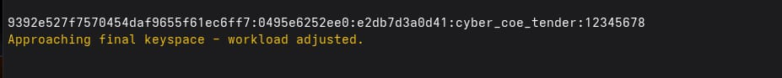
Figure 13: hashcat's cracked-password output, showing the recovered Wi-Fi password for cyber_coe_tender.
Why this matters
The password recovered here — "12345678" — is a simple, sequential number string. It appears in the very first few thousand entries of almost any common password list, which is why it was found quickly.
This demonstrates that WPA2 encryption itself was not 'broken' — the underlying handshake protocol is sound. The weakness exploited here was a weak, guessable password, not a flaw in Wi-Fi encryption.
A longer, random, non-dictionary passphrase (14+ unrelated characters, or a random passphrase of 4-5 unrelated words) would not be found this way in any practical amount of time.

Step 12 — Records kept from the session
Alongside the raw capture, airodump-ng and related tools also produced a set of supporting log files — CSV summaries of networks seen, a Kismet-format network log, and a plain-text netxml log — which were kept as supporting evidence of the session.
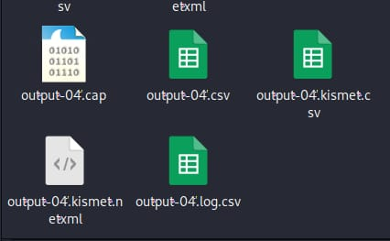
Figure 14: Supporting capture logs generated during the session (.cap, .csv, Kismet .csv, and .netxml files).

4. Summary
In short: the wireless adapter was set to monitor mode, the target network was identified and its traffic captured, a short burst of deauthentication frames forced a connected device to reconnect, and that reconnection was recorded as a WPA2 handshake. The handshake was converted into hashcat's format and, using the rockyou.txt list of leaked passwords, hashcat correctly guessed the network's password — "12345678" — within the wordlist run.

Recommendation
The network owner should change the Wi-Fi password to a long, random passphrase that does not appear in common wordlists, and consider enabling WPA3 and Protected Management Frames (802.11w) where supported, which make this style of deauthentication attack significantly harder to carry out.

